**Video quality Enhancement using super-resolution**

**Problem statement**

Super-Resolution (SR) covers a set of techniques, which is used to improve the resolution of a video sequence or a single frame. In this, a fusion SR algorithm has been used, where High-Resolution (HR) images are constructed from several observed Low-Resolution (LR) images. The term super-resolution has been applied to a wide variety of problems ranging from blur removal by deconvolution in single images through to the creation of a single high-resolution image from multiple low-resolution images having sub-pixel relative displacements. The goal is to increase the resolution (number of pixels) in the image while at the same time adding appropriate high frequency information.

**Background**

In super-resolution (SR) image reconstruction, post processing is used to obtain images with resolutions that go beyond the conventional limits of the uncompensated imaging system. The addition of new high frequency information is fundamentally an ill-posed problem since there are many high resolutions images which, under any given smoothing and sub-sampling process, will give rise to the same low resolution image. In the absence of additional information, the best we can hope to do is to find a high resolution image which is perceptually plausible so as to give the viewer the impression of viewing an image which is of higher quality than the original. Similar goal will be applied to the problem of video resolution enhancement. The imaging system considers various captures LR images with minimum local motion from several digital cameras, which are attached one to each other by an M×N array, calling this framework a MC system. In general, the majority of applications based on MC are focused on image-based rendering and visual surveillance, integrated in several fields as satellite or underwater imagery. Due to the high downfall in the cost of camera sensors, it will be possible in a near future to find several imaging sensors inside a typical consumer camera, being common to find applications of image enhancement using multiples sensors.

**Methodology**

The video Super Resolution algorithm used as a basis in this work belongs to the “fusion” category.

1. *Baseline Super Resolution (BSR) algorithm:* The BSR algorithm execution can be divided into three independent stages as shown in Fig. 1. Motion Estimation, Shift & Add, and Fill Holes. This process is shown below

Working window

HR image

3

CF

7

6

5

2

1

Shift & Add

Fill Holes

Motion estimation

Fig:1 Stages of BSR algorithm

This process is repeated for each frame (Current Frame, CF) using a Working Window (WW), which includes the backward and forward frames considered in the SR process. The output HR sequence is related to the LR sequence resolution by the scale factor parameter.

*B. Adaption of the BSR algorithm to Spatial SR:* The Baseline SR algorithm has been adapted to work with spatial and temporal information from a MC system.

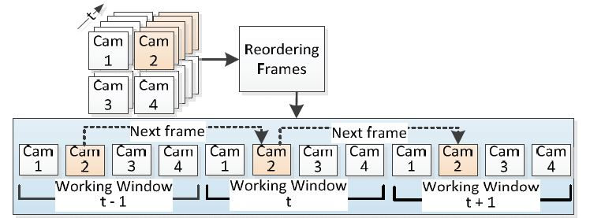

Fig 2: BSR adaption to Spatial SR

**Experimental design**

**Dataset:** Video dataset will be used for experimentation and evaluation.

**Evaluation measures:** Compression Loss, Artifacts, and Visual Quality can be computed for evaluation.

**Hardware and software requirements**

Python based Deep Learning libraries will be exploited for the development and experimentation of the project. Training of the data will be conducted on NVIDIA GPUs.